

BILKENT UNIVERSITY ENGLISH LANGUAGE PREPARATORY PROGRAM MATERIALS DESCRIPTION FORM
LEVEL: ELEMENTARY(CEFR A1&A2.1)

THEME: Unit 3 Cultural Studies | TITLE OF THE MATERIAL:Unit 3 Vocabulary Revision

Please tick the course package the material will be used in.
- Q Skills Intro | ◻

SKILL: Vocabulary | OBJECTIVE(S) (Tick and fill in as appropriate) Students will be able to  - Practice Unit 3 words

PREPARED BY: ELLP Instructors

PART A : Look at the definitions below and find the words to complete the crossword.
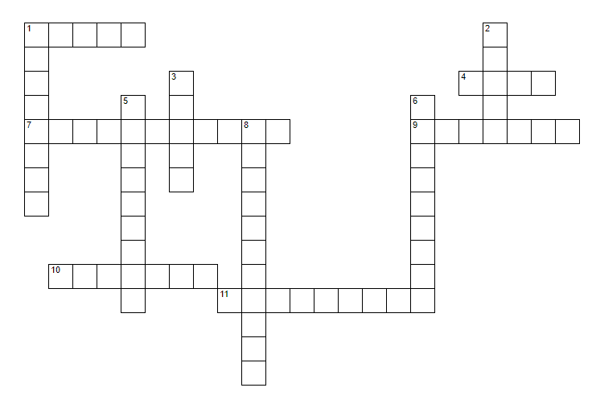

 | ACROSS
1 | not frozen or in a can
4 | the amount of money that you need to buy or do smt.
7 | the things that you use to make a meal
9 | smt. that you make or grow to sell
10 | habits, ideas or beliefs of a country
11 | smb. who does a job willingly without being paid
 | DOWN
1 | a series of special events, performances, etc that often takes place over several days
2 | to stay away from someone or something, or not use something
3 | relating to milk or products made using milk
5 | to do something enjoyable because it is a special day, or because something good has happened
6 | smb. who watches an event, sport
8 | following the customs that have continued for a long time

PART B: Complete the sentences with the words in the box. There are two extra words.

Special tidy neighbour ingredients usual visit festivals avoid celebrate
popular spectators break product stressed fresh cultures
volunteer energy dairy traditional untidy

- I love working abroad and meeting people from different _____________.
- Mix all the _____________ for the sauce in a bowl.
- He works on a _________ farm so he gets up very early in the morning to milk the cows.
- Beşiktaş won 4-0 in front of 42,000 _______________.
- My best friend is very helpful. She helps in a local school as a __________ three days a week.
- The dancers were wearing ___________ African costume.
- It’s Dad’s birthday and we’re going out for a meal to _____________.
- The beans are __________ from the garden.
- Christmas is one of the main _____________ in the Christian calendar.
- I try to ___________ supermarkets on Saturdays - they're always so busy.
- When we are on holiday, our ______________ waters our plants.
- He does not want to _______________ anyone’s heart so he chooses his words carefully.
- I will clean the house tomorrow because I do not have any ____________ now.
- Football is a very _______________ sport in Turkey so most men like watching football matches.
- My brother is very _______________ so I do not want to share my room with him.
- People usually get sick when they are ___________________.
- I generally ____________ up my room once a week but then it gets messy again the next day.
- Visiting grandparents is a _____________ practice in Bayrams in Turkey.
19. We go out for dinner as a family on __________________ days like birthdays .

